51

51

**Step 3.**P**assage Latchbolt Handing Instructions**

* All Passage Latchbolts are supplied

handed to accommodate inward 1

openning doors.if you have an outward opening door,use the following instruc-

tions to band the latchboit correctly. 3

TO HAND THE LATCH

2

1. remove face plate.
2. pull and rotate the latch boit.
3. replace face plate to set in place.

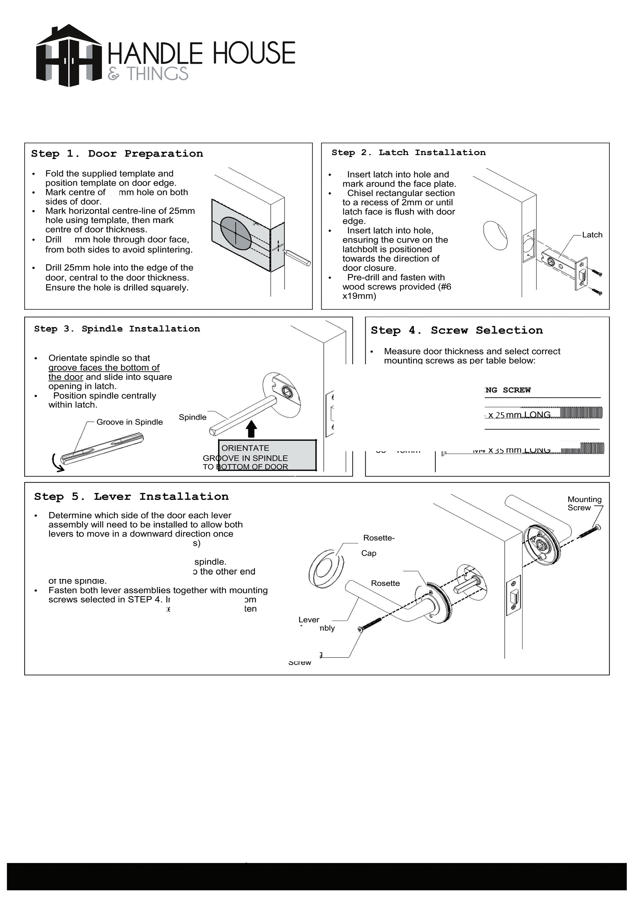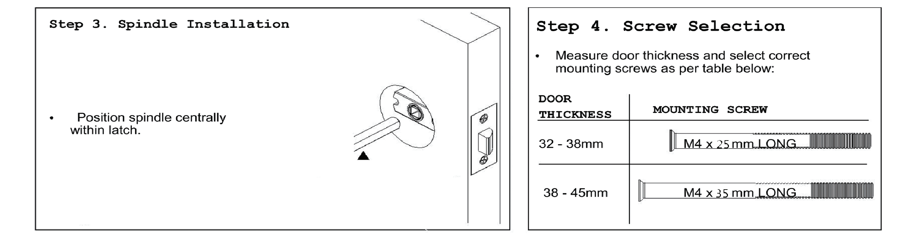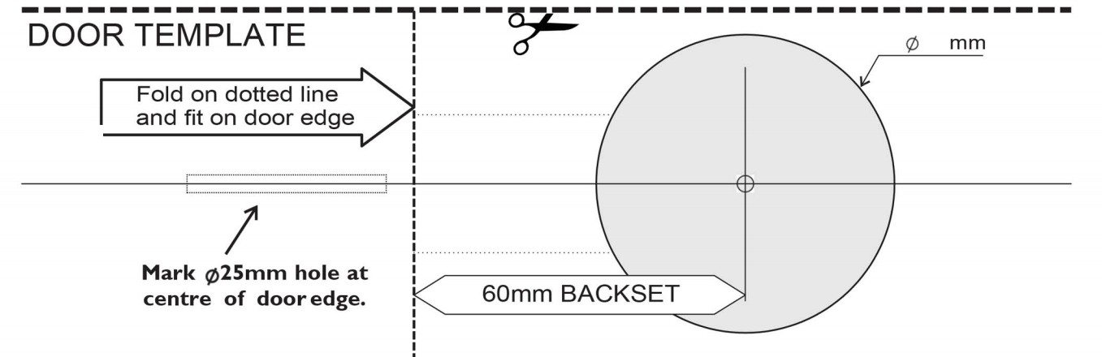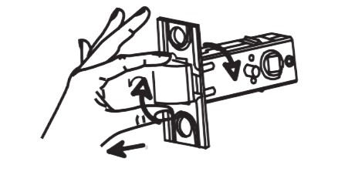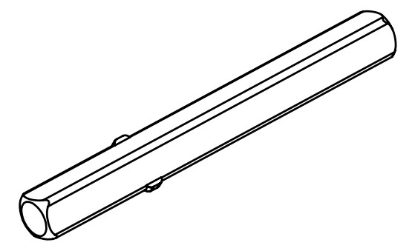

4 5

Spindle

**ORIENTATE**

**GROOVE IN SPINDLE TO BOTTOM OF DOOR**

52

# not to scale

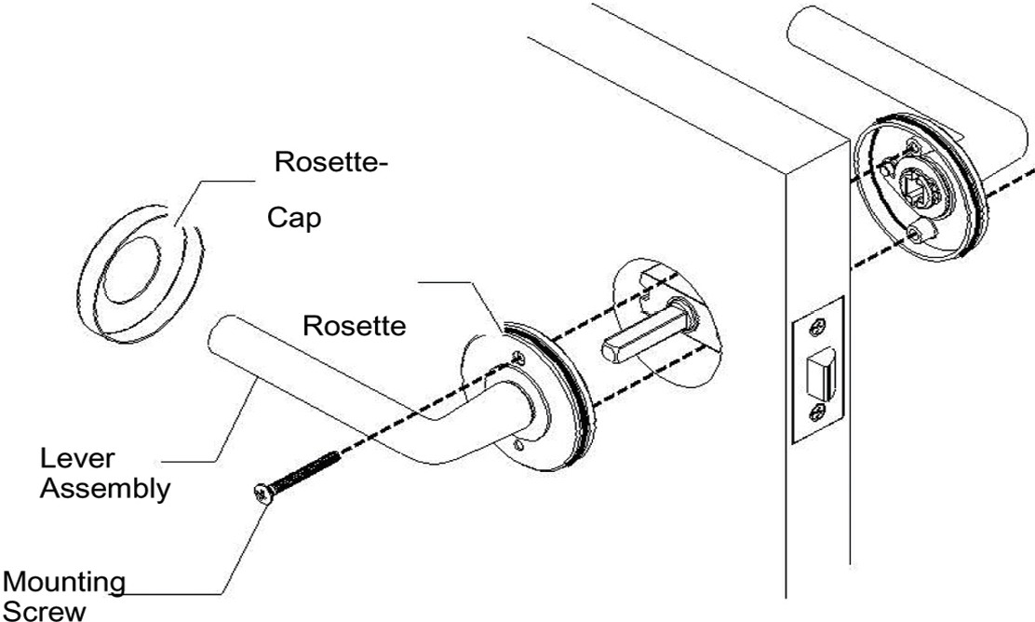

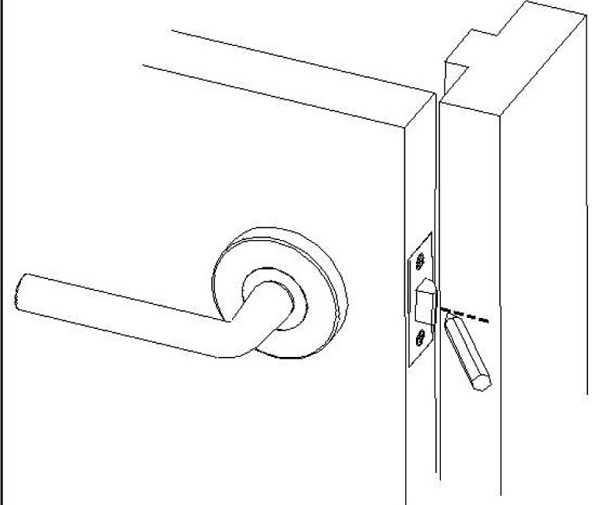

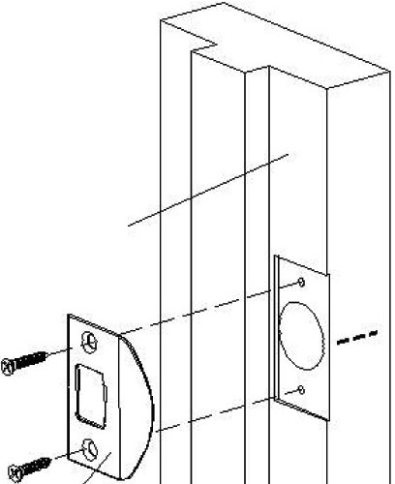

# 52

51

**Fold on dotted line**

**and fit on door edge**

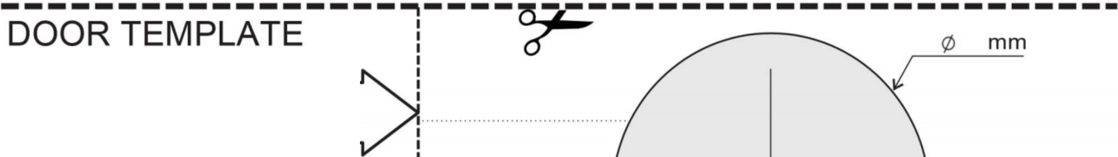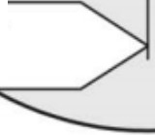

**Step** 6 . **Lever Installation**

•

Mounting

Screwz

_/

•

•

•

Determine which side of the door each lever assembly will need to be installed to allow both levers to move in a downward direction once installed. (Holes on bottom of levers)

Remove both Rosette-Caps.

Place one lever assembly onto the spindle.

Place the other lever assembly onto the other end of the spindle.

* Fasten both lever assemblies together with mounting screws selected in STEP 4. Install one screw from either side through the countersunk holes. Tighten both screws.

**Step 7. Strike Plate Installation**

•

Door Jamb-

•

Gently close the door until latchbolt rests on door jamb. Mark centre of latchbolt on door jamb, this mark can be used to position strike plate.

Mark and drill 25mm hole inside the jamb to a depth of 12mm .

* Position the strike plate and mark around. Chisel recess until strike plate sits flush with jamb face.
* Fasten the 2 wood screw (#6x19mm) supplied.

Strike Plate

*I*

**Mark ¢25mm hole at**

**centre of door edge. 60mm BACKSET**

nontotot tsocsacleale